**POWER BI PROJECT**

Explanation:

Identifying these products can be crucial for investigating potential quality issues, customer dissatisfaction, or mismatches between customer expectations and product features. Further analysis could focus on understanding the underlying reasons behind the return rates for specific products and implementing strategies to mitigate returns and improve overall customer satisfaction.

Top of Form

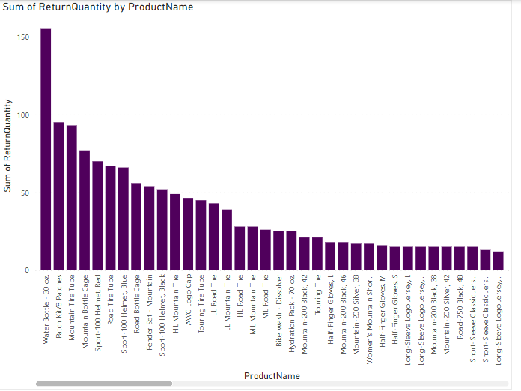

Explanation:

The analysis of total quantity sold for 2017 by country reveals varying sales volumes across different regions. Certain countries stand out as significant contributors to the total sales volume, indicating potential market opportunities or areas for further expansion.

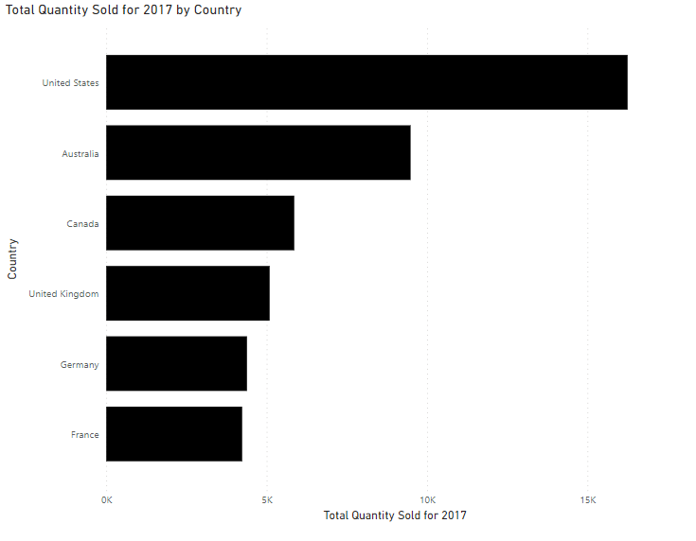

Explanation:

The analysis of the sum of product prices by country provides insights into the revenue generated from sales across different regions. It identifies which countries contribute the most to the total revenue, indicating lucrative markets or areas for further expansion. Understanding the revenue distribution by country can inform strategic decisions regarding international sales strategies, localized pricing adjustments, and targeted marketing efforts to maximize revenue growth and market penetration.

Top of Form

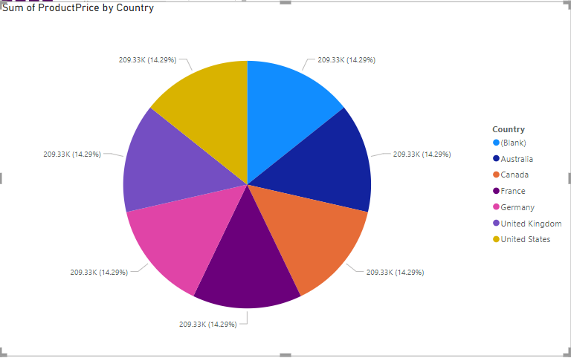

EXPLANATION:   
 The tree map chart showcasing the sum of return quantity by category and subcategory names offers a clear visualization of return patterns across different product categories and subcategories. It reveals which categories or subcategories are most prone to returns, indicating potential areas for quality improvements or customer satisfaction enhancements.

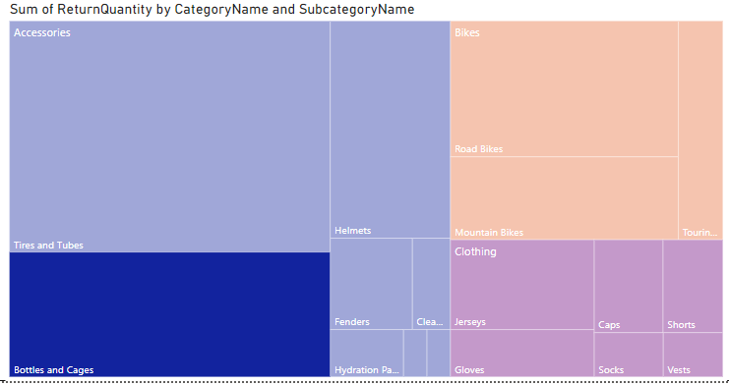

EXPLANATION:

The line chart depicts the total revenue generated by each product model, revealing which models contribute the most to overall sales. It highlights potential pricing disparities among different models, suggesting areas for pricing optimization or product portfolio adjustments. Understanding these revenue trends can inform strategic decisions aimed at maximizing profitability and enhancing product offerings.

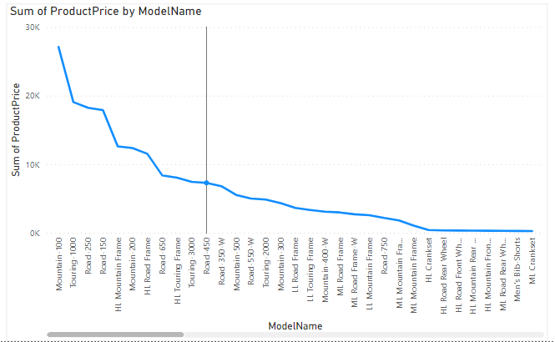

EXPLANATION:

Analyzing the average product price by model name offers insights into pricing dynamics across product models. It reveals which models command higher or lower average prices, indicating potential variations in perceived value or market positioning. Understanding these price differences can inform strategic decisions regarding product development, pricing strategies, and market segmentation to optimize revenue and profitability.

